Answer the questions below with respect to the following ERD of a simple real estate company.

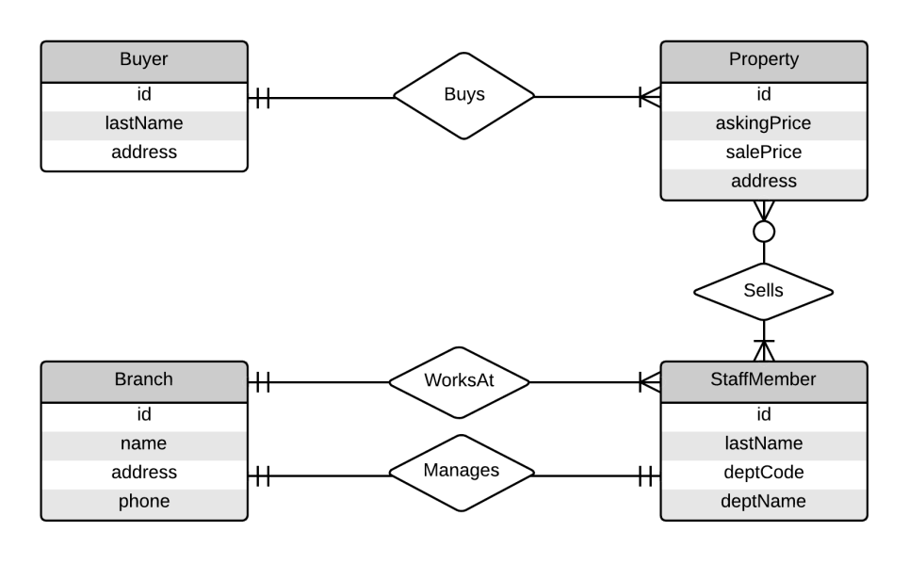

1. Write sentences (in English) to describe the all of relationships of a **Staff Member** in the diagram, including relevant cardinality.

Many Staff Members work at each Branch.

Staff Members work at only one Branch.

Exactly one Staff Member manages each Branch.

Staff members manage only one Branch.

Many Staff Members sell each of some amount of Properties.

1. Can the total of all **Property** sales for an individual **Staff Member** be calculated? If so, how? If not, why not?

Assuming we don’t care that other staff members were involved in the sale, yes. All we need to do is join StaffMember to Property, and find all Property entries related to the particular StaffMember. Then we sum all of the values in the salePrice field.

1. Can a **Branch** have one or more **Staff Member**s in it? Why or why not?

I am unclear whether WorksAt and Manages are two separate relationships, one of which is true, or are both active on every Branch/StaffMember pair.

If the former, then yes, there may be any amount of Staff Members greater than zero at any given Branch.

Assuming the latter, no, there can only be one Staff Member at each Branch. This is because they must also be the manager, of which each Branch has only one.

1. Can a **Buyer** buy several **Properties**? Why or why not?

Yes. The relationship between Buyers and Properties is exactly one Buyer to one or more Properties.

1. In *directly* converting the ERD to a set of relations, one of the converted entities would ***not*** result in a 3NF relation. Which entity is this? What would you have to do to make it 3NF?

For a model to be 3NF, it must first be 2NF. Likewise, to be 2NF, it must first be 1NF. The relationship between Properties and Staff Members is a many-to-many relationship, where each Staff Member is associated with many Properties, and each Property is associated with many Staff Members.

To make this 1NF, it needs to be made into a separate table with entries consisting of a Property and a single Staff Member. I believe this is also 2NF and 3NF.